ARIMA MODEL

**For XRP**

MAE: 0.2320

RMSE: 0.5276

MAPE: 19.63%

R²: -0.2324

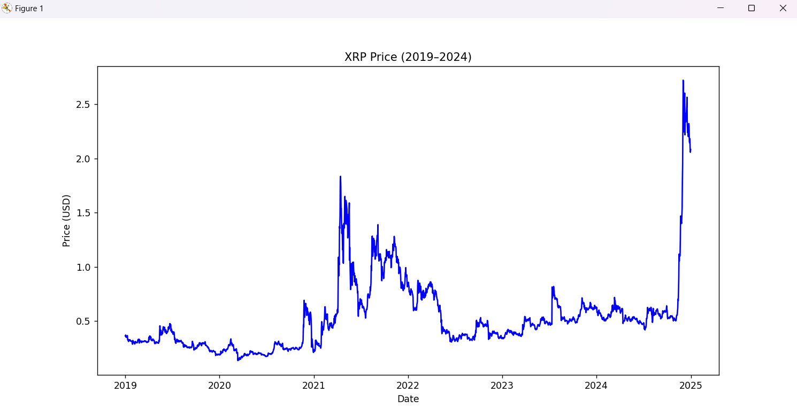

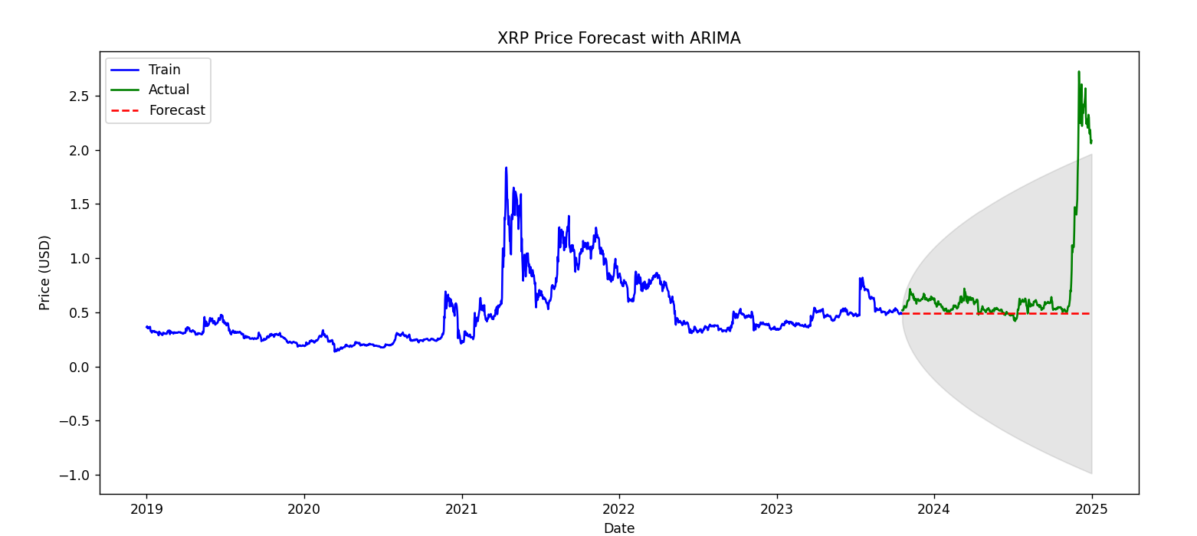

Etherium

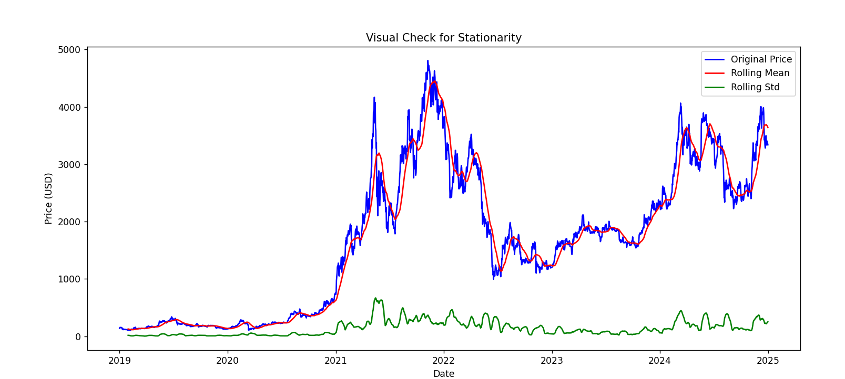

MAE: 1315.5660

RMSE: 1444.4450

R²: -4.8656

MAPE: 43.12%

Etherium with log transformation and differentiating

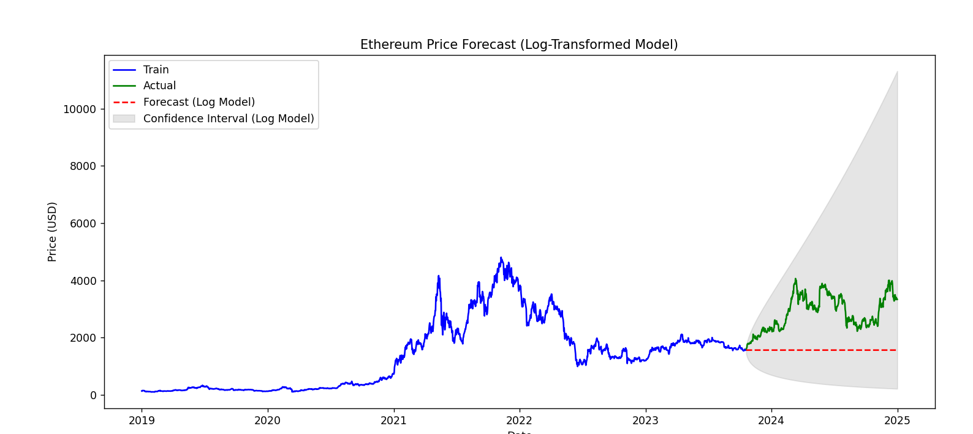

Evaluation Metrics for Log-Transformed Model:

MAE: 1315.4323

RMSE: 1444.3267

MAPE: 43.12%

R²: -4.8646

Evaluation Metrics for Log-Differenced Model:

MAE: 1317.8366

RMSE: 1446.5131

MAPE: 43.20%

R²: -4.8824

CARDANO

MAE: 0.2418

RMSE: 0.3124

MAPE: 40.77%

R²: -1.4128